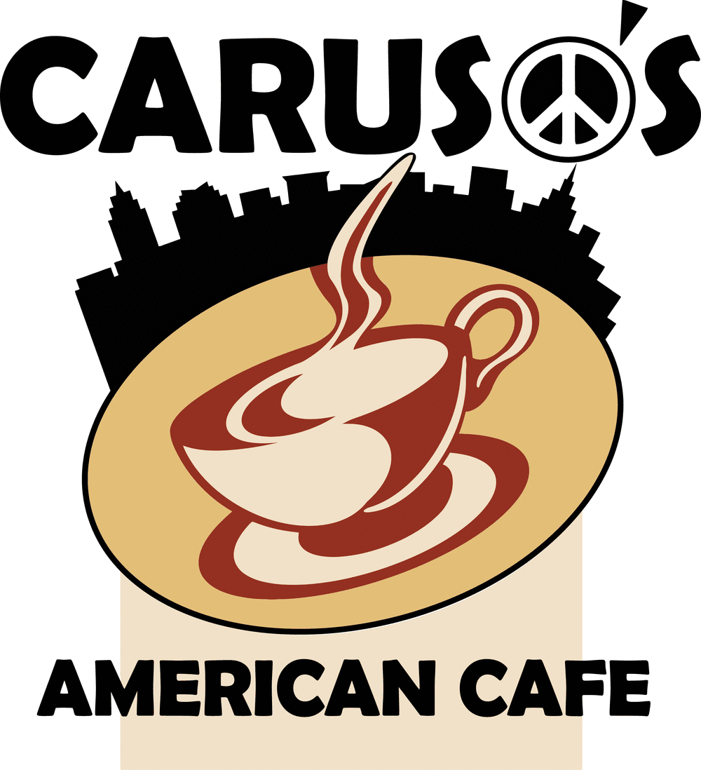
Financial Analysis
Estimated costs per location.
 | Express | American Cafe
Franchise Fee | $15,000 | $40,000
Lease Deposit | 5% rent total | 5% rent total
Leasehold Improvements | $5,000 | $30,000
Equipment/Furniture | $35,000 | $65,000
Signage | $3,000 | $8,000
Utilities, Ins., Licenses | $3,000 | $6,000
Opening Inventory | $8,000 | $12,000
Grand Opening Promos | $4,000 | $8,000
Total Amount | $73,000 | $167,000
Working Capital | $6,000 | $10,000
Est. Total | $81,000 | $177,000

Caruso’s American Cafe Forecast and Business Model
Costs Fixed & Variable | Sales $750 Day | Sales $1,000 Day | Sales $1,500 Day
Lease Amount Monthly | $4,500 | $150(Daily rent) | $150(Daily rent)
Food Cost | 33% - $247.50 | 33% - $330 | 33% - $495
Labor Cost | 15% - $112.50 | 15% - $150 | 15% - $225
Utilities/Insurance | 3% - $22.50 | 3% - $30 | 3% - $45
Admin Fees | 2% - $15.00 | 2% - $20 | 2% - $30
Royalty Fees | 4% - $30.00 | 4% - $40 | 4% - $60
Total Costs | $427.50 | $570 | $645
Total Profit Daily | $322.50 | $430 | $855

Avg. Monthly Profit $9,675 $12,900 $19,350
The numbers shown above are our monthly averages in our Ohio locations, depending on size and type of concept being used. Cleveland Brand Concepts corporate office cannot guarantee this profit for every location but if our systems of operation are followed correctly it greatly increases your chances of success.

